Software Design Assignment 1

The semester just started and we already need a vacation :(

Student: Gavrilă Tiberiu-Valentin

Contents

1. Use Case Diagram 2

2. Database Diagram 3

3. Class Diagram (sorry, full version) 4

4. Class Diagram (cleaned-up and visible version) 4

# Use Case Diagram

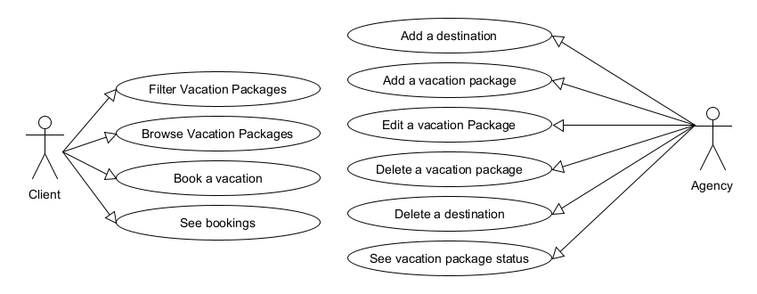

# Database Diagram

# Class Diagram (sorry, full version)

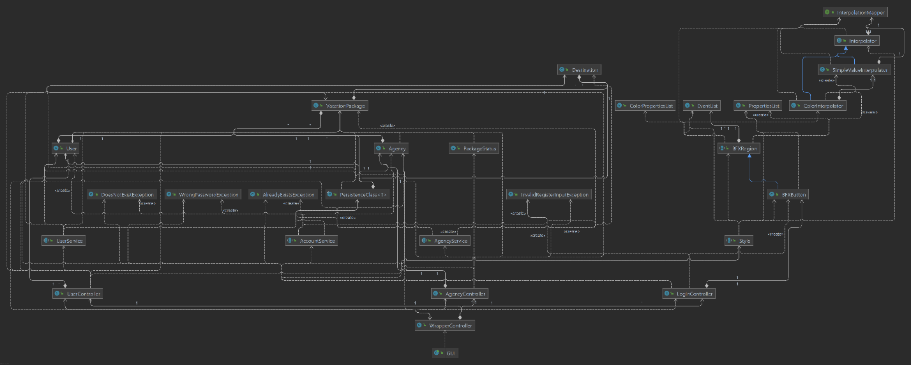

# Class Diagram (cleaned-up and visible version)

